## Group members

Sam Breen-Tester, overseer, speaker, and organiser.

Bing Zhang-facilitator, writer, budgeter, risk and conflict management and organiser.

Zirui Wang-Writer and organiser and budgeter.

Amer Al Hafez-Writer, and overseer.

Keren Chinaka- Writer and overseer

Sonam Bajpai-writer and speaker/presenter.

## Story mapping

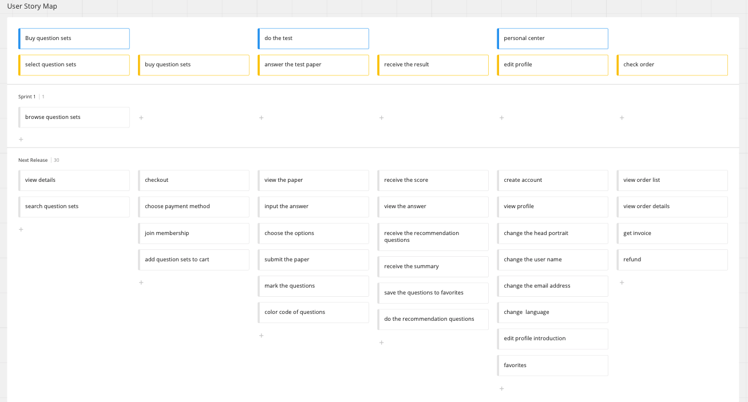

Backlog

|  |  |  |  |  |
| --- | --- | --- | --- | --- |
| Rank | name | Estimated size | status | description |
| 1 | Browse question sets | 4 | completed | an online shop to display the question sets in  several subjects |

## Estimation Duration

Start date: February 1st

Deliver date: December 1st

Total: 10 months

Every sprint duration: 20 days

|  |  |  |  |  |  |  |  |
| --- | --- | --- | --- | --- | --- | --- | --- |
| Phase | Activity | TO | TL | TP | TExpected  (PERT) | Standard Deviation | Milestone |
| Sprint 1 | Browse question sets | 16 | 19 | 28 | 20 | 2 |  |
| Sprint 2 | View details | 6 | 10 | 14 | 10 | 1.33 |  |
| Create my account | 6 | 10 | 14 | 10 | 1.33 |  |
| Sprint 3 | Buy question sets | 16 | 19 | 28 | 20 | 2 | Online shop |
| Sprint 4 | View my order | 6 | 10 | 14 | 10 | 1.33 |  |
| Edit my account profile | 6 | 10 | 14 | 10 | 1.33 | Online shop |
| Sprint 5 | View the paper | 6 | 10 | 14 | 10 | 1.33 |  |
| Input the answer | 3 | 4 | 11 | 5 | 1.33 |  |
| Choose the options | 3 | 4 | 11 | 5 | 1.33 |  |
| Sprint 6 | Submit the paper | 3 | 4 | 11 | 5 | 1.33 |  |
| Receive the score | 3 | 4 | 11 | 5 | 1.33 |  |
| View the answer | 6 | 10 | 14 | 10 | 1.33 | Do the test |
| Sprint 7 | Receive the recommendation question | 16 | 19 | 28 | 20 | 2 |  |
| Sprint 8 | Do the recommendation question and get feedback | 6 | 10 | 14 | 10 | 1.33 |  |
| Receive the summary | 6 | 10 | 14 | 10 | 1.33 | Do recommendation related questions |
| Sprint 9 | Favorites | 6 | 10 | 14 | 10 | 1.33 |  |
| Save the question to favorites | 6 | 10 | 14 | 10 | 1.33 |  |
| Sprint 10 | Refund | 3 | 4 | 11 | 5 | 1.33 |  |
| Get invoice | 3 | 4 | 11 | 5 | 1.33 |  |
| Membership | 6 | 10 | 14 | 10 | 1.33 | Account and subscribe |

Gantt Chart

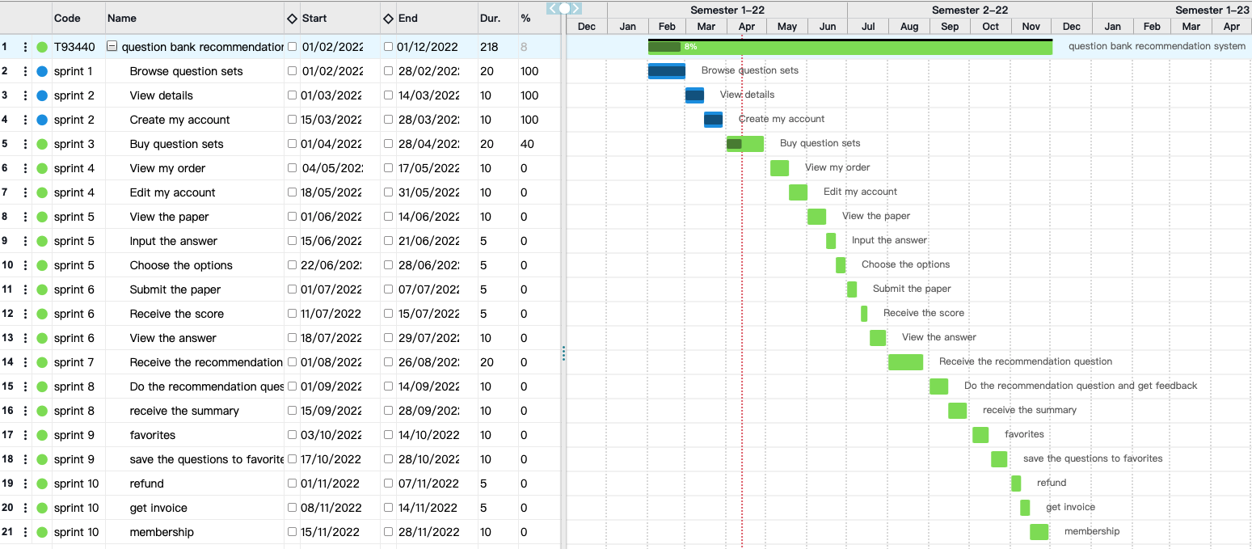

## Resources Estimation

|  |  |  |  |  |
| --- | --- | --- | --- | --- |
| **Resources Estimation** | | | | |
| **Staff type** | **Grade/Experience** | **N Months** | **Activity** | **Additional info** |
| Project Manajer | Senior | 10 M / Full Time | Plan, Manage and Monitor the project |  |
| Resources & funding coordinator | Senior | 10 M / Full Time | Manage and monitor the resources and control the costs |  |
| WEB developers | Senior | 10 M / Full Time | Full stack & database development, maintanence, deployment |  |
| UI/UX developer | Senior | 10 M / Part Time | Design and develop the user interface and experience |  |
| App tester | Senior | 10 M / Part Time | Conduct a check on the code and the web app performance during and after the development period |  |
| **Equipment** | **N Months** | **WP/ Activity** |  |  |
| Laptops | 10 Months | Project monitoring, Development, and Testing |  |  |
| Tools and software | 10 Months | Project monitoring, Web app Dev., UI/UX Dev., Testing |  |  |
| Internet connection | 10 Months | Connect to the network |  |  |
| Printers/Scanners | 10 Months | Printing/scaning |  |  |
| monitor | 10 Months | develepment |  |  |
| Material | WP/Activity |  |  |  |
| server | development |  |  |  |
| website domain | development |  |  |  |
| pen | design |  |  |  |
| books | design |  |  |  |

## Stakeholder Engagement Matrix

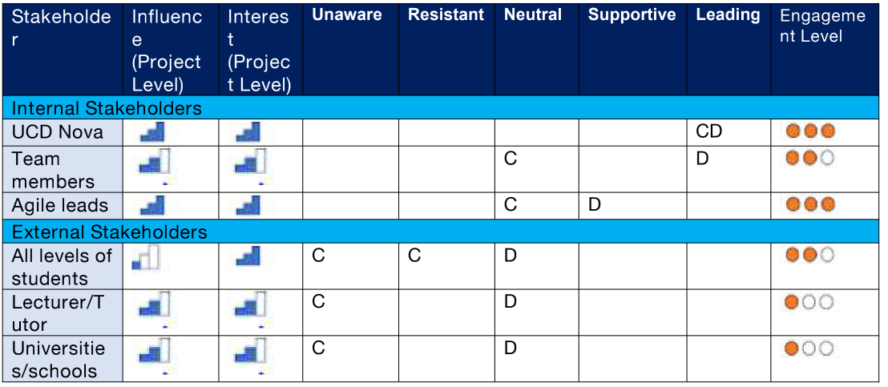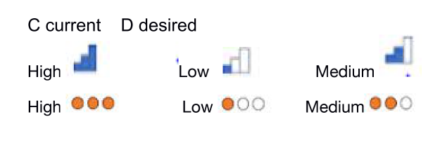

**Stakeholder Register:**

|  |  |  |  |  |  |  |  |
| --- | --- | --- | --- | --- | --- | --- | --- |
| **Name** | **Role On Project** | **Organization** | **Responsibility In Project** | **Grid Interest** | **Grid Power** | **Stakeholders Requirements** | **Strategy to gain support or reduce obstacles** |
| **UCD Nova** | Sponsor | UCD | Funding, Final decision maker | 10 | 10 | Ensures scrum and agile deliverables budget and delivery time | Providing reports on sprint outcomes, graphs, and the project’s growth after every sprint. |
| **Team members** | Technical | UCD | Technical Responsibility of the full project | 8 | 7 | Design, Build, Develop and Test the user story created as part of each sprint. | Frequent and daily communication (Standup, email, phone calls, chat, and Ad hoc) |
| **Agile leads** | Technical and leadership | UCD | Legal and Delivery Management | 8 | 9 | Ensures user stories creation, scrum calls, agile deliverables budget, and delivery time | Daily standup calls to take updates on each user story. |
| **All levels of students** | Viewers | EU/Non-EU students | None | 10 | 4 | Finds the recommendations relevant to what they are looking for | As-Needed,  Website feedback, emails |
| **Lecturer/Tutor** | Feedback providers | UCD | None | 7 | 6 | Feedback on the student’s query raised and resolved | As-needed,  website feedback,emails,phone calls |
| **Universities/schools** | Participants | UCD | None | 7 | 6 | Number of student communications | As-needed,  website feedback,emails,phone calls |

**Communication Plan:**

***Goals:***

We communicate to lessen risks, build trust, create awareness, educate, and promote action.

· Clear definition of which communications vehicle is most effective for type comms.

· Clear understanding of the vision and mission of the team initiatives – starting with those who actually work on them – e.g. – anyone should be able to give the next major deliverable relevant to their work.

· More cohesive team spirit.

· Improved collaboration between the team members through understanding.

|  |  |  |  |  |
| --- | --- | --- | --- | --- |
| ***METHOD*** | ***AUDIENCE*** | ***CONTENT*** | ***WHY?*** | ***FREQUENCY*** |
| **Town Hall** | Platform + anyone (recorded) | Completed work, overviews of quarterly accomplishments, and messaging from the leader. | · Inspiration from the leader  · Broadcast work  · Field questions | Quarterly |
| **Stride Rooms** | Leadership, each team, total platform | Questions, general comments to the group, updates on specific services. | · Team spirit/barrier  · Cross-geo communication  · Support channel  Announcements | Ad hoc |
| **Stride chat/Individuals/Email/Phone calls** | Person to person | Ad hoc conversation | · Online chat | Ad hoc |
| **All hands/Demos** | Team | Completed work | · Agile ritual  · Shared understanding | Fortnightly |
| **Standups** | Team | What did I do yesterday, what am I going to do today, any blockers | · Agile ritual  · Team alignment  · Identify and action blockers | Daily |
| **Blogs** | Anyone who watches space | Updates, milestones, commentary on the subject relevant to the space | · Inform others  · Seek comments  · Thought Leadership | As a part of the process for all that we do |
| **Pages** | The immediate team first, external teams second | Project plans, thoughts, documentation, summaries of outcomes | · Project planning (roadmaps, one-pager, actions, project posters, retros, etc.)  · Meetings – agendas, actions, notes  · Elicit feedback  · Document plans. Etc.  · Sharing information | Continually |
| **Newsletter/Social Media** | External reach | Snapshots of initiatives and results | · Share information in a more general tone in a summarized format  · Interactions between individuals within an online community | Monthly |
| **Leadership Meeting** | Leadership Team | UCD Nova’s messages, updates, and requests  Updates from team leaders  Discussion | · Team alignment  · Information flow to and from UCD Nova and between team members  · Prioritising and strategic alignment | Weekly |
| **Leadership/Team offsites** | Direct team | Quarterly plans, forward-looking plans, discussions, and workshops | · Strategic alignment  · Teamwork  · Team bonding | Quarterly |

**Risk Register:**

|  |  |  |  |  |  |  |  |  |  |
| --- | --- | --- | --- | --- | --- | --- | --- | --- | --- |
| **Type of Risk** | **Description of Risk** | **Probability** | | | **Impact** | | | **Risk Migration Plan** | **Risk Owner** |
| **H** | **M** | **L** | **H** | **M** | **L** |
| Project Management | Miscommunication between teams |  |  |  |  |  |  | Use same communication for all teams | Project Manager |
| Design | Lack of interest in uptake from students |  |  |  |  |  |  | Look at similar projects to mimic success and interest with students | UI Team |
| Design | building/testing the  recommendation system becomes difficult |  |  |  |  |  |  | Clarify UI schedule with designers | UI Team and Testing team |
| Budget | Struggles with getting contracted with universities and lecturers |  |  |  |  |  |  | Set up contracts with universities early | Investor |
| Time | Work Delays in due to Covid-19 pandemic & lockdowns |  |  |  |  |  |  | Employ remote workers | Investor |

Risk Strategy:

* Make sure that all teams share one type of communication so that it is easier to

pass on project details

* Look at similar projects to mimic success and interest with students
* Set up contracts with universities early so that there is little delay with approval
* Clear understanding of timing concerning UI design of recommendation system and testing
* Employing workers who can work remotely so that any unseen circumstances will

not harshly slow down project.

## BUDGET

|  |  |  |  |  |
| --- | --- | --- | --- | --- |
| PROJECT BUDGET in Euro | | | | |
| **DIRECT COST** | | | | |
| PERSONNEL COST | | | | |
|  | Monthly rate*[euro] | activity#Duration | Full Time/Part time | Total Cost(euro) |
| Project Manager | 3,000 | 10 | 100% | 30,000 |
| Developer #1 | 4,000 | 10 | 100% | 40,000 |
| Developer #2 | 4,000 | 10 | 100% | 40,000 |
| UI designer | 3,000 | 10 | 50% | 15,000 |
| Tester | 3,000 | 10 | 50% | 15,000 |
| **Total Personnel** | | | | 140,000 |
| MATERIAL&CONSUMABLES | | | | |
| User Domain |  |  |  | 4,000 |
| Server |  |  |  | 2,000 |
| pen&books |  |  |  | 100 |
| **Total Consumables & Materials** | | | | 6,100 |
| EQUIPMENT | | | | |
| Laptops |  |  |  | 5,000 |
| Tools and software |  |  |  | 900 |
| Internet connection |  |  |  | 900 |
| Printers/Scanners |  |  |  | 200 |
| monitor |  |  |  | 800 |
| **Total Equipment** | | | | 7,800 |
| **TOTAL DIRECT COST** | | | | 153,900 |
| **INDIRECT COST** | | | | |
| Indirect Cost calculated at 30% of Direct Cost | | | | |
| **TOTAL INDIRECT COST** | | | | 46170 |
| **TOTAL** | | | | **200,070** |

Budget justification

At the beginning of the project chapter, we set the budget to 200,000 euros. During the 10 months, with 5 workers, we found it beyond the budget in the original plan, so we cut it down. Because the development team should follow up the whole project in 10 months, but UI and tester can work flexibly, we cut down the PM, tester and UI’s salary from 4k to 3k, and transfer the tester and UI to part-time to save budget. In total, personnel cost is 140,000.

For material and consumables, we need user domain and server which occupy the main part of this cost. In total, consumables and materials cost 6,100 euros.

For equipment, it includes laptops, monitors, tools and softwares, internet connection and printers. In total, equipment cost is 7,800.

The direct cost is the sum of personnel, equipment and materials cost, which equals 153,900 euros.

The indirect cost is 30% of Direct Cost, which equals 46,170 euros.

In total, the project budget is 200,070 euros, which is close to the original cost.

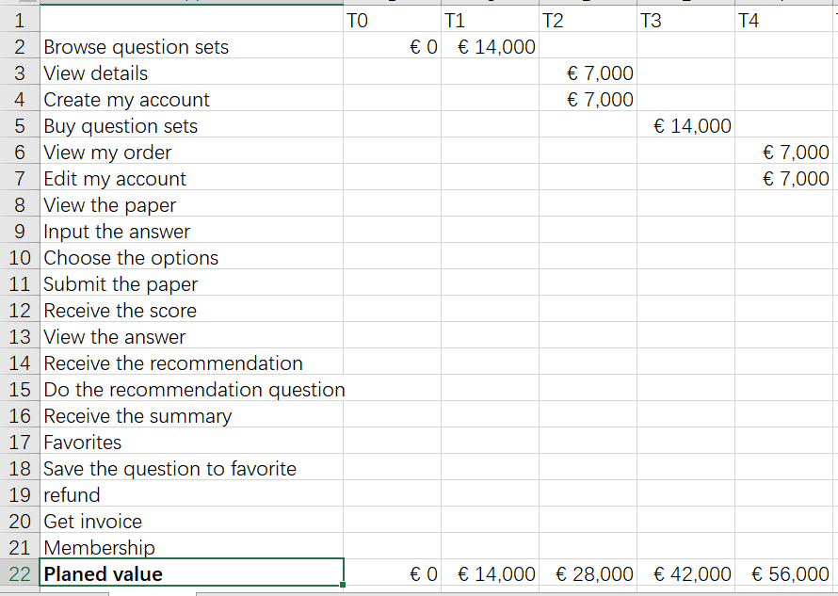

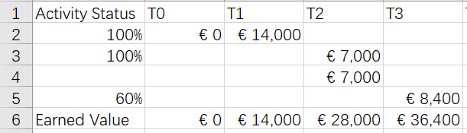

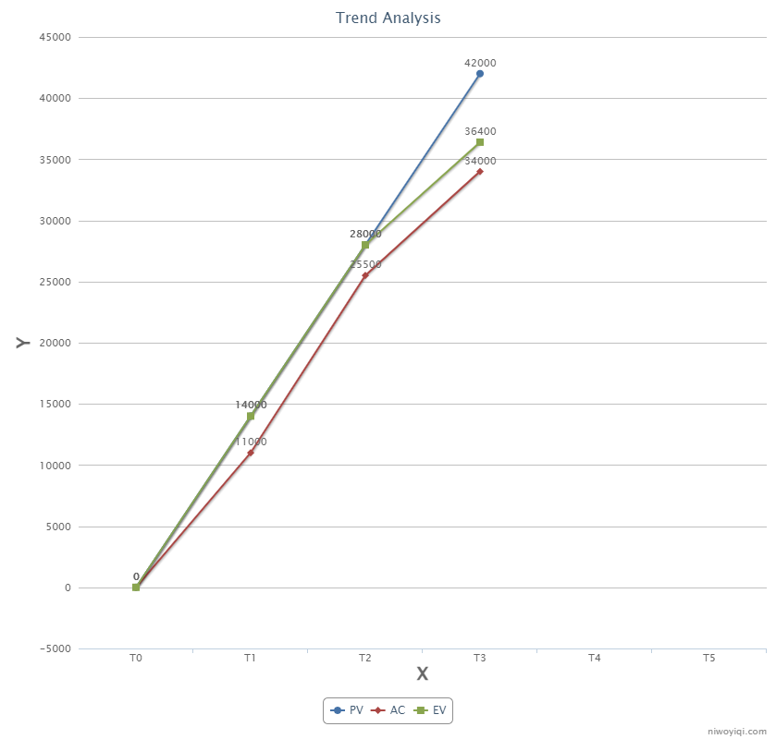

SV= EV - PV < 0 the third sprint is still progressing, so overall it looks behind schedule, but the first two sprints are on schedule.

CV = EV - AC > 0 Cost variance is underspending, there is no budget deficit within the project.

Reflection

Sam Breen 17374333

What I did

From the beginning of the project, I was proactive in trying to get everyone together which was successful with the help of Bing. After this, I organised that we started the tasks early on. After the idea was decided and the first task was upcoming to be presented. So, I then prepared myself and presented the first task. For the second task, I provided the group with the idea of using Miro for the story mapping and assistance with that Gannt chart. It allowed us to format them well. We then organised the resources to do. The estimation which I did the editing of as the overseer to check that it’s all good to submit then submitted it. Lastly regarding the budget, I worked out exactly what was needed to be done regarding the trend analysis graph.

What I enjoyed

I really enjoyed being able to participate with a good group. I found it also enjoyable to be able to work hard and make it into a good project and present it, as it brought me out of my shell a bit.

What I found difficult

I found it difficult to present initially as haven’t in a while and am not an extroverted person but like I previously mentioned I enjoyed it as it helped me learn to be more confident. The other part I found difficult was figuring out exactly what to do for the project idea as we had many good ideas.

What really worked

What really worked is our capability of working together. We worked well together and did what was needed well individually. This made us have no let-downs for work being done on any part of the project process.

What I would do differently next time

Next time I feel I would like to have the work broken more evenly even if someone insists on doing something themselves to make everyone feel they are contributing equally and not too little or too much. As well as this I would like to make it that organisation and planning was better. Lastly, stay in touch more and perhaps meet in person more rather than just over zoom.